
David Andronic

Assignment 1 – Aspire Fitness – Database Design
CIS095-1 – 2025-2026
Contents
Introduction 2
Scenario Description 2
Assumptions 4
Task 1: Entity Relationship Model 5
The Entities 5
The Relationship 5
The Entity Relationship Diagram 6
Task 2 - Physical Database Design (including Data Dictionary) 7
Part A - Skeleton Tables 7
Part B - Data Dictionary 7
Task 3 - Implementation of the Database 9
Part A – Create Tables 9
Table 1: Create table Room 9
Part B – Insert Data 9
Insert Statement 1: Inserting data into Room table 10
Task 4 - Query Design and Implementation 11
Part A – The list of Queries and their Purpose 11
Part B– SQL Queries Implemented 12
Discussion / Critical Reflection 15
Conclusion 16
Appendix 18

Assignment 1 – Design and Implement a Database

Introduction

Guidelines: Why are you doing this work? What were you asked to do? What did you do? Were you successful?

EXAMPLE: DO NOT COPY, ONLY USE AS A GUIDE
Students are required to investigate a given business-related case study which focuses on a hotel seeking to provide an online service for customers to book rooms and to check their upcoming trips. Students are required to:
- Apply conceptual / logical modelling techniques to create an Entity Relationship Model
- Develop a fully normalised set of tables
- Create the Physical Design via a set of skeleton tables and a data dictionary
- Implement the database using a set of SQL commands to create the tables and insert records into the tables.
- Design queries that are applicable for the case study (the hotel) and implement these queries.

The following document outlines the successful completion of each of the above tasks.

Scenario Description

Guidelines: Describe the Assessment Scenario about Aspire Fitness in your own words

EXAMPLE: DO NOT COPY, ONLY USE AS A GUIDE
Aspire Fitness is a local health and wellbeing business operator. They offer incredible fitness, exercising, socialising and relaxation experiences to its members. It has a gym, a multifunction sports hall, yoga and dance rooms and spa facilities. It has around 20 full-time fitness staff offering personal training, group exercise and special classes.
Aspire Fitness needs a database that can manage member’s booking of facility hiring for activities it offers for volleyball, basketball, badminton, and netball etc. and attendance of taught classes like Yoga, Tai Chi, Dance, Zumba, Pilates etc.

Aspire Fitness exhibits the following rules:
- Membership: Each customer must apply and get a membership. Each member after registration has a unique membership number. The system will need to store the membership number with member’s basic data like first name, surname, address, telephone number, email address, date of birth and any medical conditions as a member profile for the period of the membership. Membership also has attached to it the weekly charge which is composed of:
- Weekly Subscription (£10 per week)
- Extra Classes (£5 per extra class above the five allowed for free)

- Fitness Staff: The club also need to record staff data like first name, surname, role (personal trainer, class instructor, gym staff, manager, administration), and a contact phone number. Each staff member will have unique staff number.

- Facility hiring: Club members are entitled to hiring facilities for free. The facilities include:
- Main Hall (can be used for functional activities like football, basketball, netball, volleyball etc, maximum capacity 80)
- Yoga Hall (can be used for yoga, dance, combat etc, maximum capacity 25)
- Small Dance Room (can be used for yoga, dance, etc, maximum capacity 10)

Facility hiring has the following restrictions:
  - Each member can only book one facility per week for a maximum two-hour time slot
  - No facility hiring for activities can be booked overlapping another booking or reserved class time
  - Activities cannot be booked when rooms are already reserved for weekly class bookings

- Class booking: classes are fitness staff instructor involved activities. Each class must have a unique class code, class name, instructor id, day and time of delivery, maximum class size (number of people who can register). Club members can book class with the following rules:
  - Each member can only book up to five classes per week for free
  - Above five classes can be booked by members at an additional cost of £5 per class

Assumptions

Guidelines: Outline any assumptions being made regarding the case study. These assumptions may be things that could impact the constraints or the nature of the relationship between the entities.

EXAMPLE: DO NOT COPY, ONLY USE AS A GUIDE

The following are the assumptions made regarding the hotel booking system. These assumptions influence the ER Diagram and the subsequent tables and the implementation of the queries:

- A customer can make one or more bookings at a time.
- A booking is assigned to only one room
- The hotel manager needs to login to the system therefore a username and password is required to be stored for each hotel manager.
- A person may be registered as a customer however they may not necessarily make any bookings.
- All bookings made must be either for a double or single room.
- While the intent is to book all rooms in the hotel, it is possible that a room may never have been assigned a booking.
- It is possible a hotel manager may never assign a booking to a room.
- A customer will only have/use one Credit Card
- The room numbers are unique in the hotel.

Task 1: Entity Relationship Model

The ERM is a conceptual representation of the structure of a database system. It identifies the main entities within the system, the attributes associated with each entity, and the relationships between them. The purpose of developing an ERM is to ensure that the database design accurately reflects the requirements of the given business scenario before implementation begins.

For the Aspire Fitness case study, the ERM was developed to model the data required to manage members, staff, facilities, classes, and bookings. The diagram illustrates how these entities interact with one another and ensures that data redundancy is minimised through proper normalisation. Particular attention was given to resolving many-to-many relationships using junction tables, such as the ClassBooking entity, in order to maintain referential integrity and support efficient database operations.

The ER diagram was created using Visual Paradigm and serves as the foundation for the physical database design and subsequent implementation in MySQL.

The Entities
- Member – stores member details
- Staff – stores staff details
- Facility – stores facility information
- Class – stores class details
- ClassBooking – resolves many-to-many between Member and Class
- FacilityBooking – records facility reservations

The Relationship
The relationship between Staff and Class is a one-to-many relationship. One staff member can instruct multiple classes, while each class is delivered by one and only one staff member. Therefore, StaffID is implemented as a foreign key within the Class entity.

The relationship between Member and Class is logically many-to-many, as one member can book multiple classes and each class can be attended by multiple members. To resolve this many-to-many relationship and maintain normalisation, a junction table called ClassBooking was introduced. This creates two one-to-many relationships: one between Member and ClassBooking, and another between Class and ClassBooking.

Similarly, the relationship between Member and Facility is also many-to-many, as members may book different facilities and each facility may be booked by multiple members over time. This relationship is resolved through the FacilityBooking entity, which records each individual facility reservation.

Each booking entity contains foreign keys that reference the related primary keys, ensuring referential integrity and preventing orphan records within the system.

The Entity Relationship Diagram

Figure 1 illustrates the logical ER diagram developed using Visual Paradigm. The diagram shows the six core entities along with their primary and foreign keys. Many-to-many relationships have been resolved using junction tables to ensure normalisation.

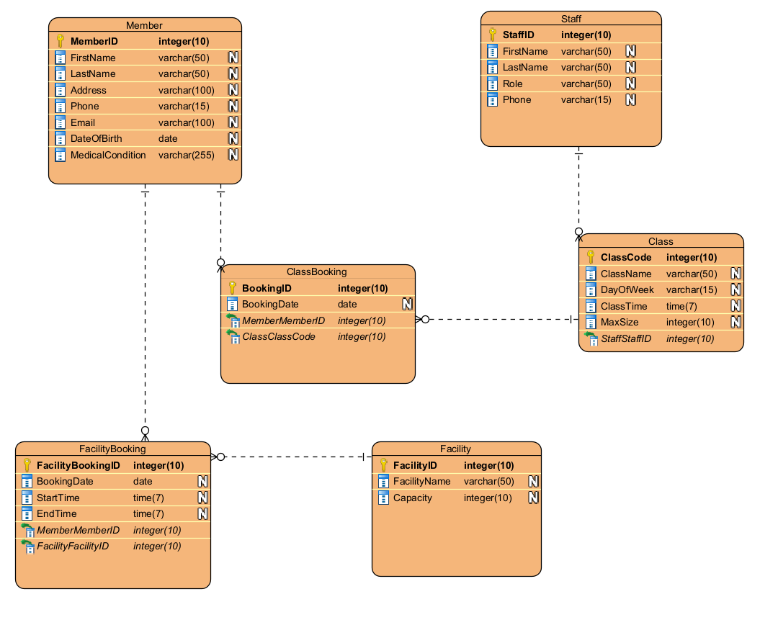

Task 2 - Physical Database Design (including Data Dictionary)

Guidelines: This section should include:
1: A statement clarifying the choice of DBMS
2: A list of the normalized tables in the form of skeleton tables.
3: The data dictionary for each table

EXAMPLE: DO NOT COPY, ONLY USE AS A GUIDE

This section contains a detailed overview of the physical design process. It includes the choice of DBMS as well as a list of the normalized tables in the form of Skelton tables along with the data dictionary for each table.

Choice of DBMS
Oracle APEX was selected as the DBMS for this assignment due to its cost-effectiveness, online accessibility via a browser without the need for installation, and its alignment with the curriculum of the next level of the BSc program level.

Part A - Skeleton Tables
The following is the skeleton tables for the Hotel Booking System. It includes a list of tables with their attributes including the Primary Key and Foreign Keys.

- Customer (CustomerID, Name, Address, Email, Phone, CCNumber)
- HotelManager (HotelManID, HotelManName)
- Room (RoomNo, RoomType)
- Booking (BookingID, StartDate, EndDate, RoomType, HotelManID*, RoomNo*, CustomerID*)

Part B - Data Dictionary
This section contains the data dictionary for the tables mentioned above (Skeleton Tables). The following tables (5 and 6) are the data dictionary and index for the Booking table.

Table 5: Data Dictionary for Booking Table
Booking
Description: This table stores the details of each booking
Field Name | Datatype | Length | Index | Null | Default Value | Validation rule | Description
BookingID (Primary) | VARCHAR2(8) | 8 | PK | No |  |  | identifies every booking
Startdate | Date |  |  | No |  | Cannot be a past date | The start date of the booking
EndDate | Date |  |  | No |  | Must be a date after the startdate | The end date of the booking
RoomType | VARCHAR2(10) | 20 |  | No |  | Single, Double | The type of room
HotelManID | VARCHAR2(8) | 8 | FK | Yes |  |  | The hotel manager who assigns a room to the booking.
RoomNo | NUMBER | 5 | FK | Yes |  |  | The room assigned to the booking.
CustomerID | VARCHAR2(8) | 8 | FK | No |  |  | The customer who makes the booking.
BookingStatus | VARCHAR2(15) | 15 |  | No |  | Pending, Cancelled, Active, Completed, Paid | The status of the booking

Indexes

The following table is the index for the booking table.

Table 6: Index for the Booking Table
Keyname | Type | Unique | Column | Null
PRIMARY | BTREE | Yes | BookingID | No

Task 3 - Implementation of the Database

Guidelines: This section should include:
1: A list of the CREATE TABLE statements showing the creation of each table
Part A – Create Tables
This section will focus on the SQL statements to Create the Tables
For each table students should
1: Show the SQL CREATE TABLE statement
2: Provide evidence that the table was created

2: A list of the INSERT statements showing the insertion of at least 3 records into each table.
Part B – Insert Data
This section will focus on the SQL statements to INSERT data into the Tables
For each table students should
1: Show the SQL INSERT statement to insert rows of data into the table (at least 3 rows per table)
2: Provide evidence that the data was inserted into the table.

EXAMPLE: DO NOT COPY, ONLY USE AS A GUIDE

This section looks at the implementation of the database using Oracle Apex. It will consist of two parts, Part A looks at creating the tables while Part B focuses on the insertion of data into each table.

Part A – Create Tables
This section will focus on the SQL statements to Create the Tables

Table 1: Create table Room

The following is the create table statement for the ROOM table.

CREATE TABLE ROOM (
ROOMNO NUMBER NOT NULL,
ROOMTYPE VARCHAR2(20) NOT NULL,
PRIMARY KEY (ROOMNO)
);

Figure 4 below shows the room table created using Oracle Apex.
<show figure 4 below>

Part B – Insert Data

Insert Statement 1: Inserting data into Room table
The following is the insert statement showing 4 records inserted into the room table using the INSERT ALL statement.

insert all
INTO ROOM VALUES (1,'Single')
INTO ROOM VALUES (2,'Single')
INTO ROOM VALUES (3,'Double')
INTO ROOM VALUES (4,'Double')
SELECT * FROM DUAL;

Figure 5 below shows the room table with the 4 records inserted.
<show figure 5 below>

Task 4 - Query Design and Implementation

Guidelines: This section should include:
1: A list of at least 7 queries and for each query state its purpose. These queries should be of higher level of complexity. Some of the queries should make use of the GROUP BY and HAVING clause while others may include aggregate functions.
2: The implementation of the SQL Queries. For each SQL query mentioned above, provide the following:
1: State the name of the query and a description
2: Describe the SQL statement in words (this shows that you understand what the SQL statement is doing)
3: Show the SQL statement
4: Show a screenshot from Oracle Apex showing the SQL code for the query and the output of the query.
5: Ensure the screenshot is easy to read and has a figure # and caption

This report is made up of 2 parts:

Part A – The list of Queries and their Purpose
EXAMPLE: DO NOT COPY, ONLY USE AS A GUIDE

This section includes a list of queries that the Aspire Fitness will require along with an explanation of each query and the SQL implementation of the query.

PART A: The list of queries and their purpose

Provide a list of 7 queries that will be required by Aspire Fitness.
For each query give it a name and state what it will provide or how it will be used by Aspire Fitness.

Table 3: List of queries and their purpose
# | Query | Justification
1 | List of all customers | The Hotel may require of list of their customers if they are hosting customer appreciation events or mailing out a specific offer to them.
2 | Hotel Manager Listing | This is a listing of the hotel management staff to assist with rostering of staff
3 | Rooms in use on a given day | To ensure the cleaning staff is well rostered, they would need to know which rooms are in use on a given day.
4 | Room Number for a given guest on a current booking | Often guests may forget which room they are in or sometimes a call comes in for a guest and needs to be routed to the room. For a given name, this query provides the room number the guest is staying in.
5 | Rooms available on given day ordered by room type | The Hotel Manager is required to assign a room to a booking. In order to do so, a list of available rooms will assist in assigning a booking. This should be sorted by room type.
6 | Number of rooms per room type | The hotel may require the number of rooms for each room type as part of capacity planning.
7 | The top customers – based on bookings made | The hotel is always interested in knowing who their top customers are. This counts the number of bookings made by customers to determine the top customers. The report is sorted in descending order by the number of bookings.
8 | The top customers – based on nights stayed | The hotel is always interested in knowing who their top customers are. This counts the number of nights each customer has stayed at the hotel to determine the top customers. The report is sorted in descending order by the number of nights stayed.
9 | Top months based on bookings made | It is important for the hotel to determine their peak periods as prices may vary based on the number of bookings received. During peak periods, the room price is higher than during off-peak periods. This report indicates the month and how many bookings start in that month.
10 | Customers who have made more than 5 bookings at the hotel | The hotel may find it important to identify customers who have made more than a certain number of bookings (e.g. 5). This report will provide a list of customers who meet that criteria.
11 | Customers who have stayed more than 5 nights at the hotel | The hotel may find it important to identify customers who have stayed more than a certain number of nights (e.g. 5). This report will provide a list of customers who meet that criteria.

Part B– SQL Queries Implemented

Query 1: LIST OF ALL CUSTOMERS

# | Query | Justification
1 | List of all customers | The Hotel may require of list of their customers if they are hosting customer appreciation events or mailing out a specific offer to them.

This uses the SELECT * statement to show all the columns FROM the Customer table. The ORDER BY clause orders the output by the customerID.

SQL Statement:

SELECT *
FROM Customer
ORDER BY customerID;

Figure 1 below shows the screenshot of the query and the results obtained from running the query.

Figure 1: List of all customers
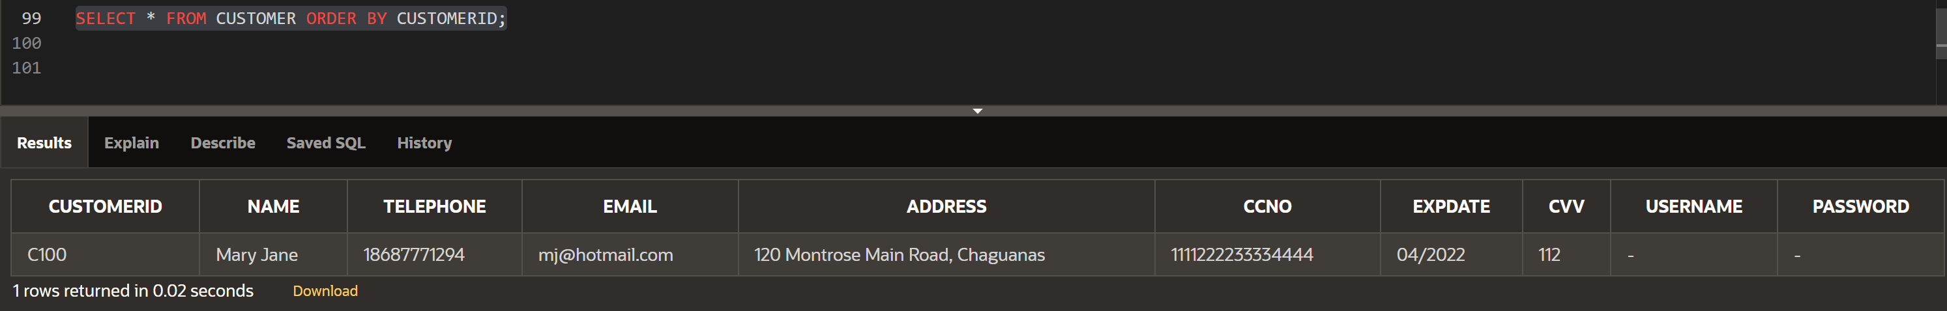

Query 2: LIST OF HOTEL MANAGERS

# | Query | Justification
2 | Hotel Manager Listing | This is a listing of the hotel management staff to assist with rostering of staff

This query selects just the HotelManagerID and Name from the Hotel Manager table. The SELECT is used to specify the columns (HotelManagerID, Name) and the FROM specifies the table (HotelManager).

SQL Statement:

- SELECT HotelManID, Name
- FROM HotelManager

Figure 2 below shows the screenshot of the query and the results obtained from running the query.

Figure 2: List of hotel managers
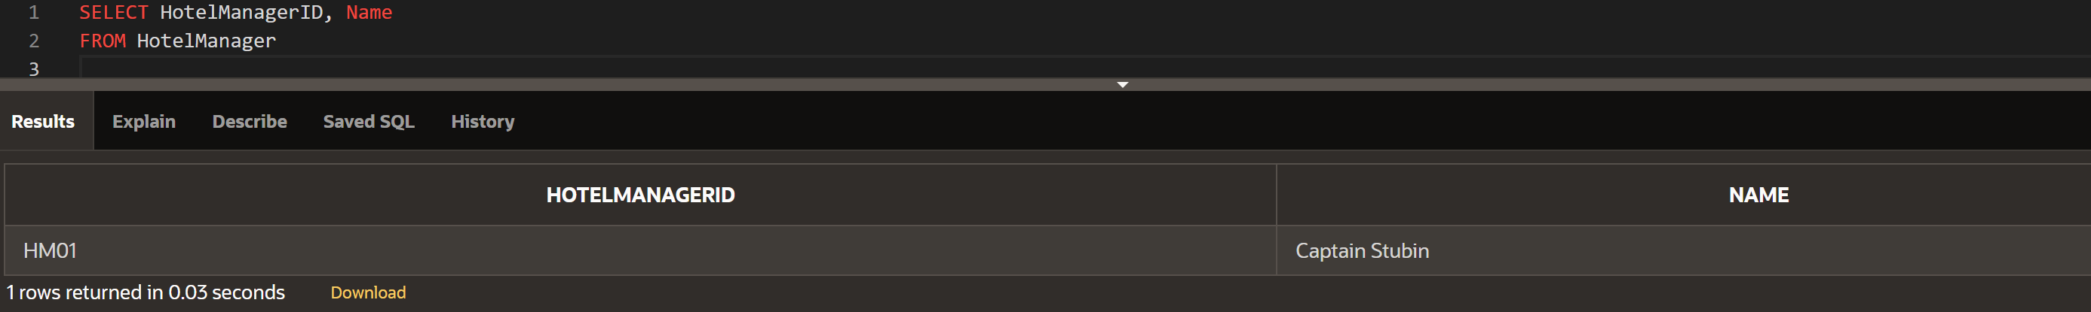

Discussion / Critical Reflection

Guidelines: This part is important.

Basically, you are evaluating what you have done. Did you achieve all the required specification of the Assignment brief? If not, why not? Discuss the problems you encountered and how you overcame them.

Explain what issues you were facing and how you address them in each individual steps of the data system design to ensure the efficient and smooth daily operation of the sport club and make sure the business success.

Did you give yourselves enough time to accomplish this work? Was it harder than you expected? What have you learned from tackling this Assignment?

Did this work enhance your understanding of the database design and implementation? Did it motivate you to learn more SQL and about NoSQL databases?

If you had to undertake this or something similar again would you tackle it differently?

What improvements or enhancements would you recommend for a future iteration of this project?

EXAMPLE: DO NOT COPY, ONLY USE AS A GUIDE

In this assignment, one must be able to learn, design and utilize the components of a Relational Database Management System for a Hotel Booking Management System. This comprised of areas such as determining the different entities, their attributes as well as relationships among the entities. These were the building blocks that allowed for creation of an ER Diagram, which was created using the application Visual Paradigm. Once this was established, various tables containing proof of Normalisation, Skeleton Tables and Data Dictionaries were also developed.

Finally, the creation of tables for each of the entities, insertion of data and queries were all conducted using the SQL language within the Oracle APEX application. Therefore, with the information presented throughout this report together with supporting proof of the screenshots and SQL code displays that this assignment was completed successfully and in a short space of time due to prior knowledge of these topics with no issues. However, there were new topics that were learnt while compiling this project. For example, the process of Normalisation was at first troubling to grasp its concepts but eventually became understandable once it was applied to the data within this project. Another example was the use of a different development application for databases, which was Oracle APEX. This software application was extremely simple to navigate in addition to performing the various SQL statements and viewing the records formed. Lastly, I gained more knowledge of the SQL
language in relation to performing queries with the records that would have been stored in the database. With all of these factors, I am interested in learning more about databases, the SQL language and looking at other database applications to produce higher quality projects similar to this assignment.
If I had to partake in another assignment parallel to this one, I would attempt it differently by constructing multiple figures and tables to have different views of a project in addition to looking into the current software to learn about the advanced features that they would offer. I would recommend that future iterations of this project should require more descriptive analysis of what the queries were based on, for example a scenario which one has to solve and exactly what steps were performed to accomplish a successful query.

Conclusion

Guidelines: Discuss What were you asked to do? Did you achieve it?

EXAMPLE: DO NOT COPY, ONLY USE AS A GUIDE

The learning outcome of the unit suggests that at the end of the unit students should utilise problem-solving skills to put together information from different sources in order to design, develop and implement a databases.

This assignment tested each of those learning outcomes whereby I was required to design and implement a database for a Hotel Booking System. Using the case study provided in the assignment brief, I had to develop an ER Model, Normalize the relations to 3NF, Develop the physical table design, Implement the database by creating the tables and inserting data into them and finally design and implement SQL Queries.
I was able to successfully achieve each of these and thereby meet the learning outcomes of the unit!

Appendix

Guidelines: This is optional and is only used if there is anything else that you might want to include that does not fit well into the main report body.

